1] import java.util.Scanner;

public class Main{

public static void main(String[] args){

int N;

Scanner sc=new Scanner(System.in);

System.out.println("Enter the No.of elements");

N=sc.nextInt();

int[] a=new int[N];

System.out.println("Enter the elements");

for(int i=0;i<N;i++)

{

a[i]=sc.nextInt();

}

System.out.println("Display before sorting");

for(int i=0;i<N;i++)

{

System.out.print(a[i]+ " ");

}

System.out.println(" ");

int[] sort=new int[N];

sort=Ascending(a);

for(int i=0;i<N;i++)

{

System.out.print(sort[i]+ " ");

}

}

static int[] Ascending(int X[])

{

for(int i=0;i<X.length-1;i++)

{

for(int j=i+1;j<X.length;j++)

{

int num=0;

if(X[i]>X[j])

{

num=X[j];

X[j]=X[i];

X[i]=num;

}

}

}

return X;

}

}

Output

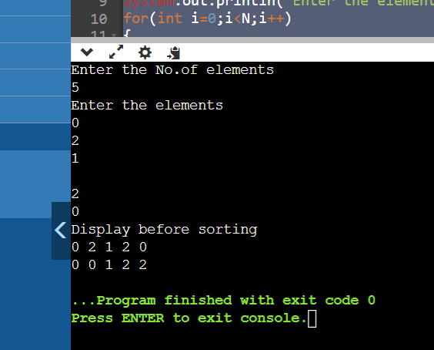

2] import java.util.Scanner;

public class Main{

public static void main(String[] args){

int N;

Scanner sc=new Scanner(System.in);

System.out.println("Enter the number of elements");

N=sc.nextInt();

int[] a=new int[N];

System.out.println("Enter the elements");

for(int i=0;i<N-1;i++)

{

a[i]=sc.nextInt();

}

System.out.println("The elements are");

for(int i=0;i<N-1;i++)

{

System.out.print(a[i]+ " ");

}

System.out.println("");

int b;

b=MissingNumber(a);

System.out.println("The missing element is " + b);

}

public static int MissingNumber(int X[])

{

int sum,add=0,MissNum,number;

number=X.length;

sum=number\*(number+1)/2;

for(int i=0;i<X.length;i++)

{

add=add+X[i];

}

MissNum=sum-add;

return MissNum;

}

}

Output:

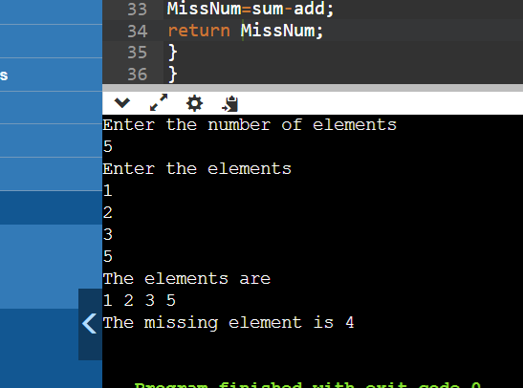

4[import java.util.HashSet;

import java.util.Scanner;

public class Main{

public static void main(String[] args) {

Scanner sc = new Scanner(System.in);

System.out.print("Enter the number of elements in the first array: ");

int n = sc.nextInt();

int a[] = new int[n];

System.out.print("Enter the elements of the first array: ");

for (int i = 0; i < n; i++) {

a[i] = sc.nextInt();

}

System.out.print("Enter the number of elements in the second array: ");

int m = sc.nextInt();

int b[] = new int[m];

System.out.print("Enter the elements of the second array: ");

for (int i = 0; i < m; i++) {

b[i] = sc.nextInt();

}

System.out.println(doUnion(a, n, b, m));

}

static int doUnion(int a[], int n, int b[], int m) {

HashSet<Integer> unionSet = new HashSet<>();

for (int i = 0; i < n; i++) {

unionSet.add(a[i]);

}

for (int i = 0; i < m; i++) {

unionSet.add(b[i]);

}

return unionSet.size();

}

}

Output

